Brandeis Blocks World Scenario 1

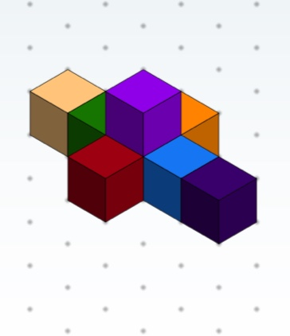

(has hidden white block below purple block)

Brandeis Blocks World Scenario 2

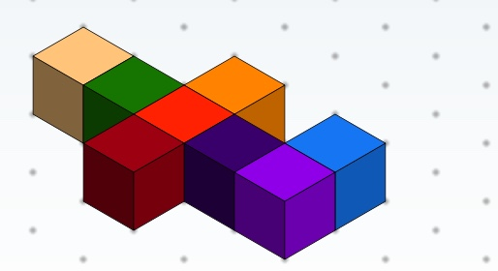

Brandeis Blocks World Scenario 3

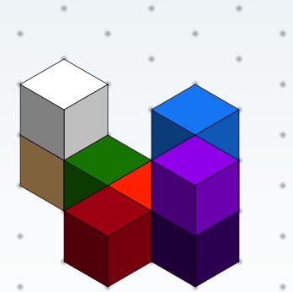

(has hidden gray block below blue block)

Brandeis Blocks World Scenario 4

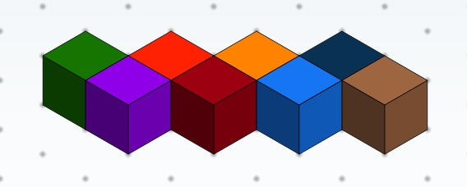

Brandeis Blocks World Scenario 5

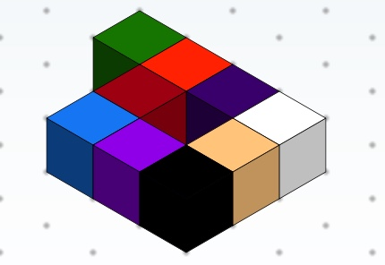

Brandeis Blocks World Scenario 6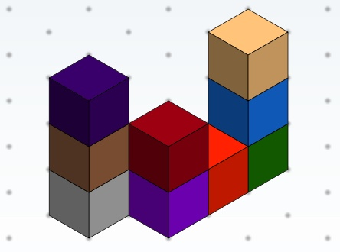

(has hidden white block to the right of the gray block)